CST 4530 LABS

A1. TCP/IP configuration information.

|  |  |  |  |  |  |
| --- | --- | --- | --- | --- | --- |
| Pc | IP Address | Subnet Mask | Default Gateway | MAC | Hostname |
| Primary | 192.168.100.238 | 255.255.255.0 | 192.168.100.1 | 88-53-2E-70-AE-2C | DESKTOP-Q175990 |

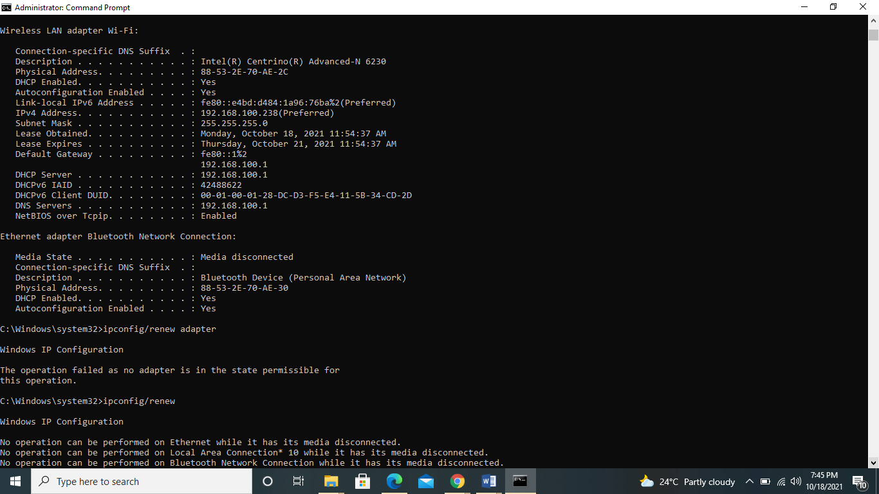

USING THE PING COMMAND:

Ping google server

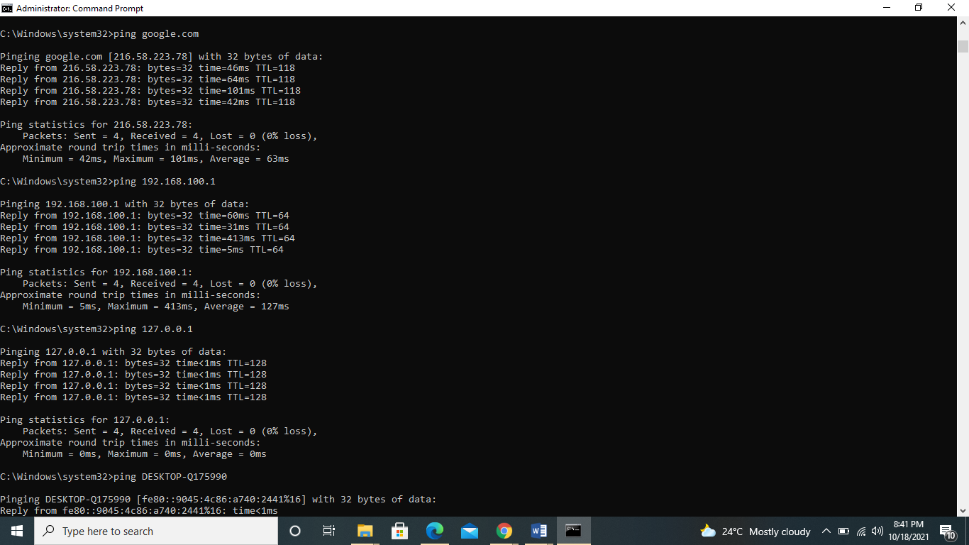

Ping the IP address of the default gateway.

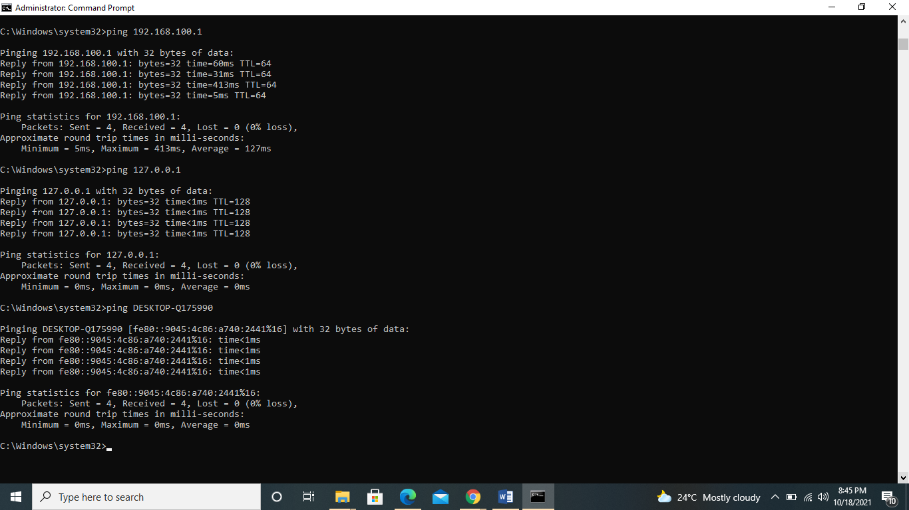

Connection to default gateway is successful which means there is physical connectivity to the router on the local network and possibly the rest of the world.

Ping the IP address of a DHCP or DNS servers: default gateway, DHCP and DNS are the same.

Ping the Loopback IP address of this computer.

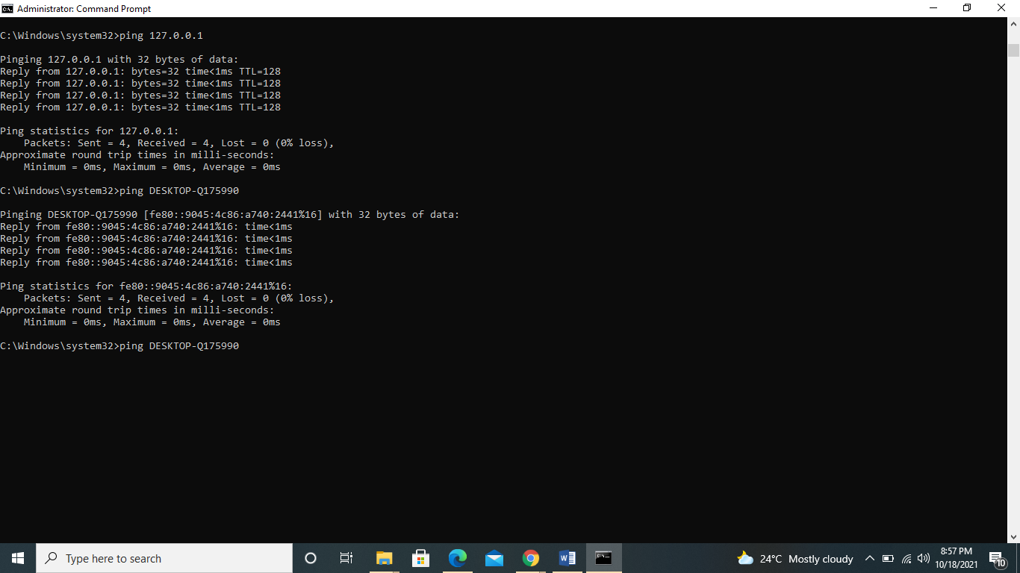

Ping the hostname of another computer



Network connectivity and path information – tracenet

Type tracert at the command prompt, followed by a host name or IP address from your working area

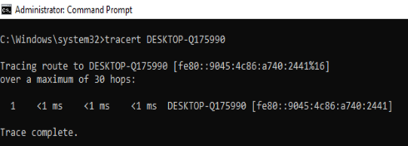

  Tracert DESKTOP-Q175990

Type tracert command, followed by a local host name or IP address. E.g. tracert [www.google.com](http://www.google.com).

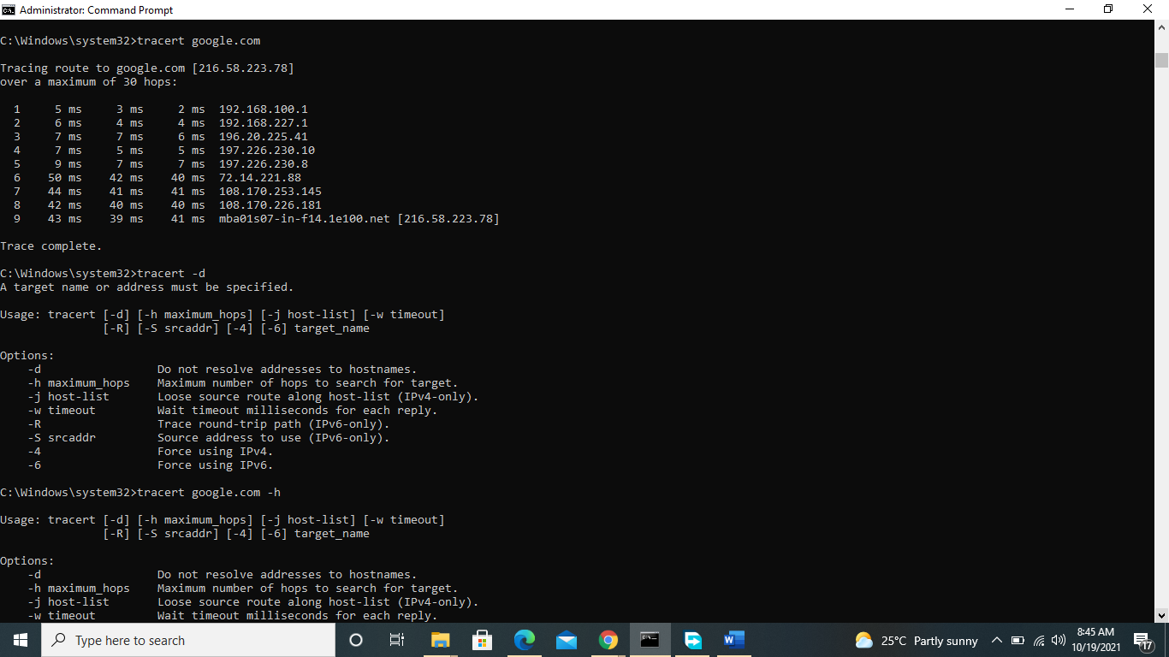

For the first tracert, it does just 1 hop to the destination as it is on the same network. The second tracert command which is external, takes a total of 9 hops to reach the destination google.com at an estimated time of 60 seconds.

A4. Address resolution protocol – arp

C:\windows\system32>arp -a

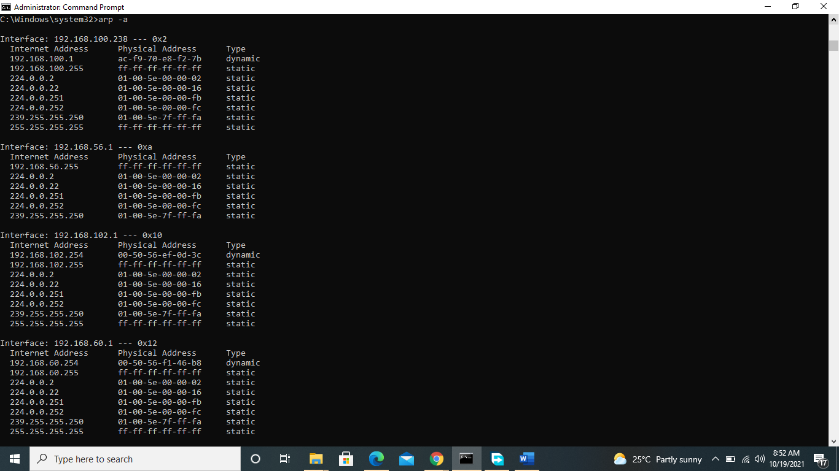

A 5. NET VIEW

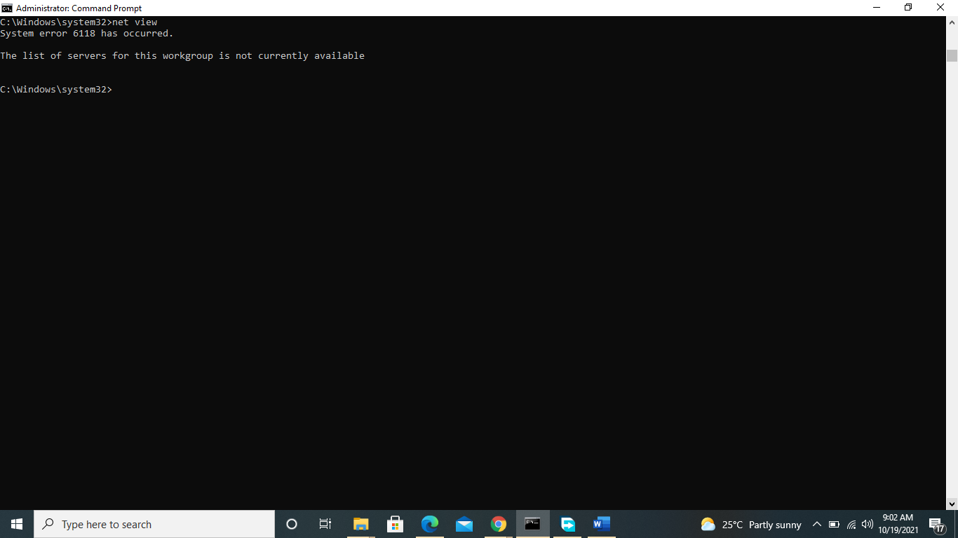

Using the NETSTAT utility.

Netstat -e 10

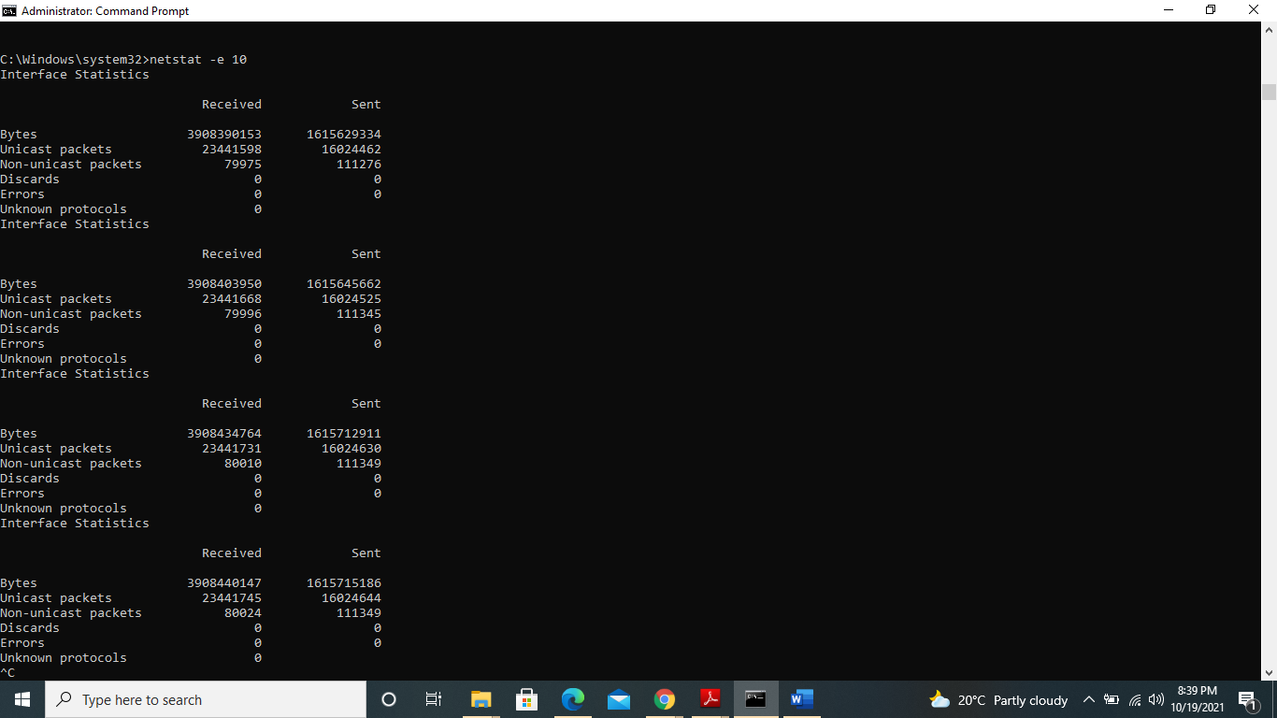

Display the statistics of all the protocols

IP statistics.

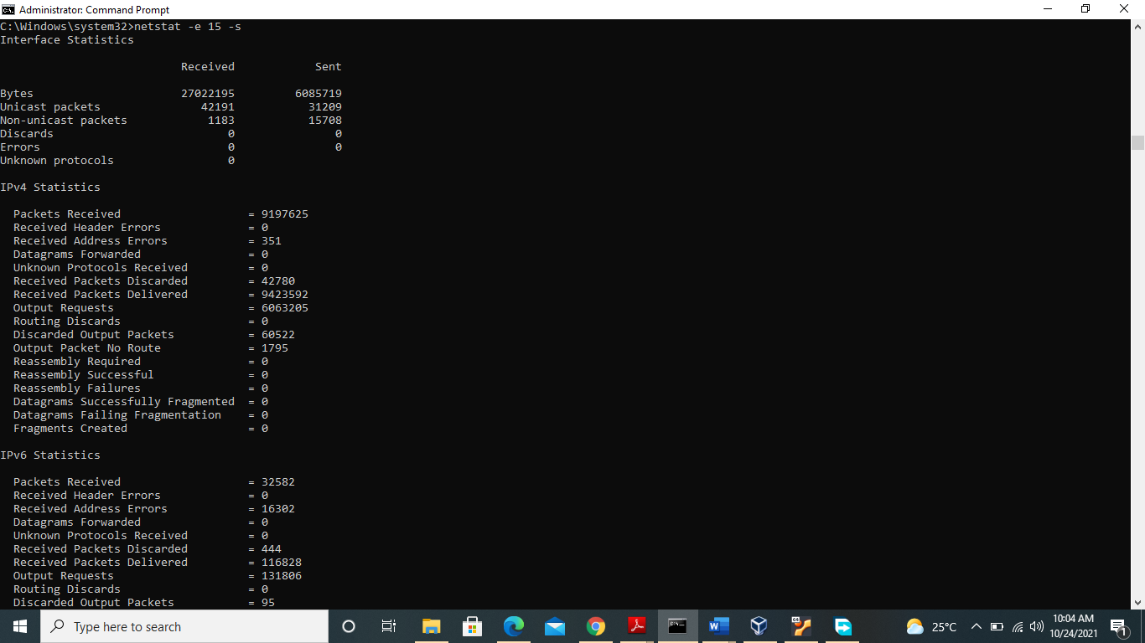

IP Packets sent and received in a given 15 second interval.

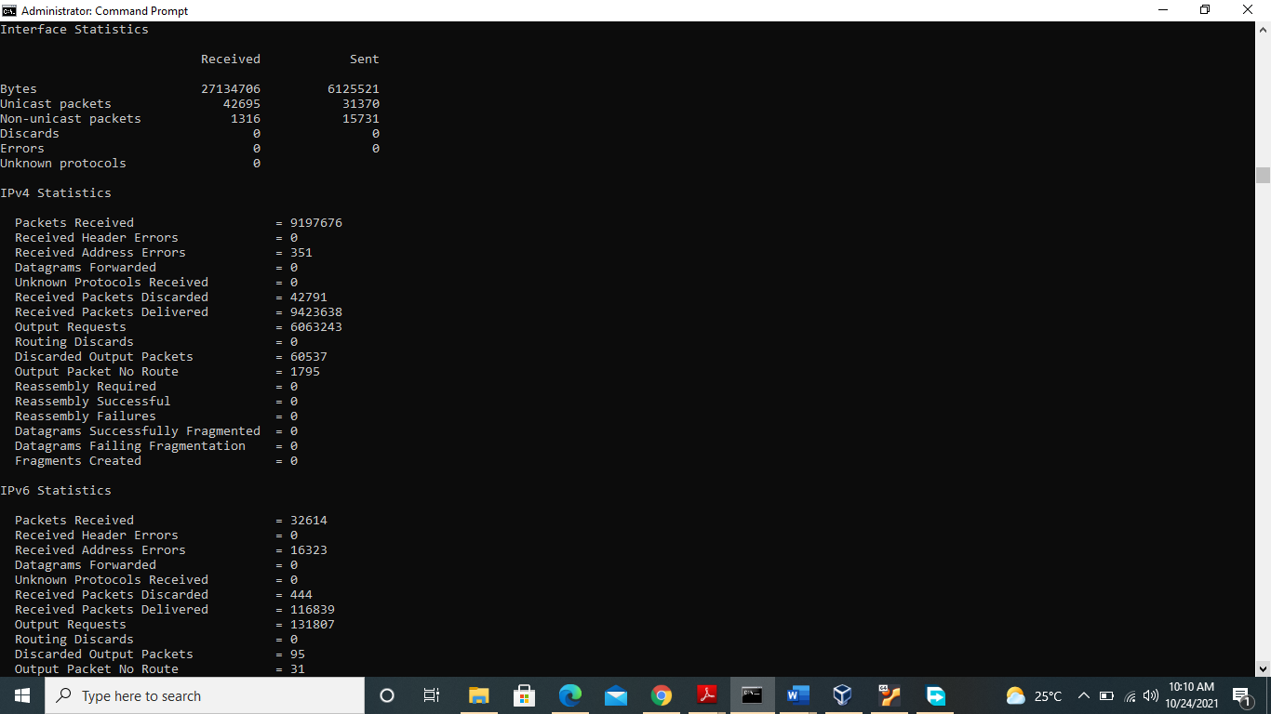

Command : netstat -e 15 -s , was used to display ethernet statistics for all protocols within a 15 second interval.

TCP/UDP Statistics since bootup

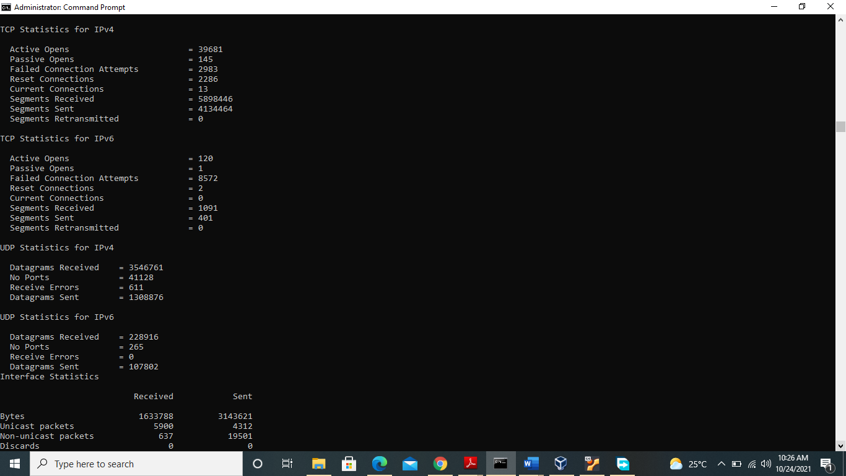

TCP/ UDP Statistics in a given 20 second interval

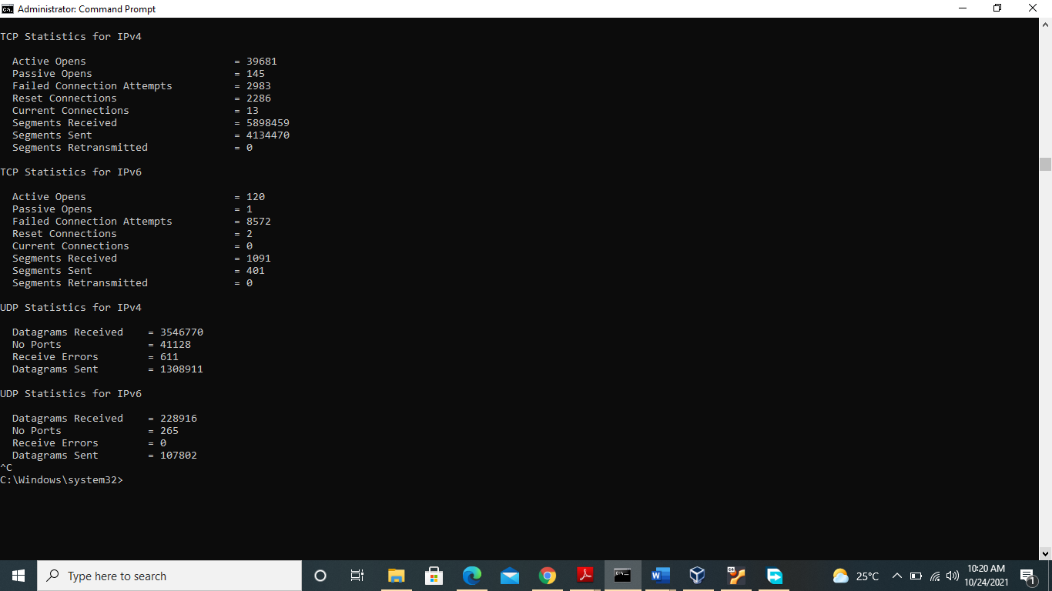

ICMP Statistics since bootup.

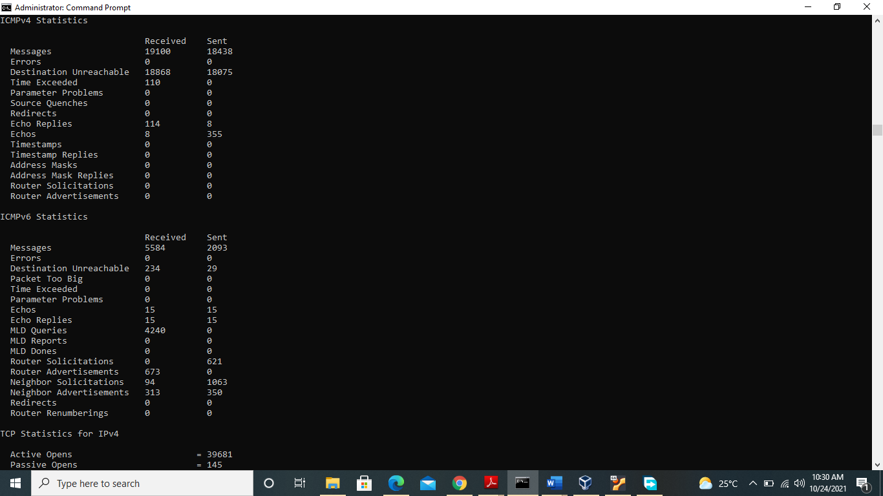

ICMP Statistics in a given 20 second interval.

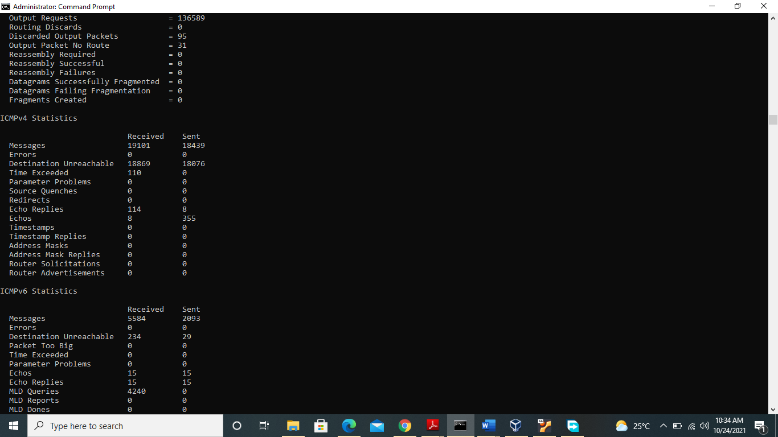

Command : netstat -e 20 -s was used to display ethernet statistics for all protocols within a given 20 second interval. And record is taken for TCP ,UDP and ICMP.

USING the netstat -bno command.

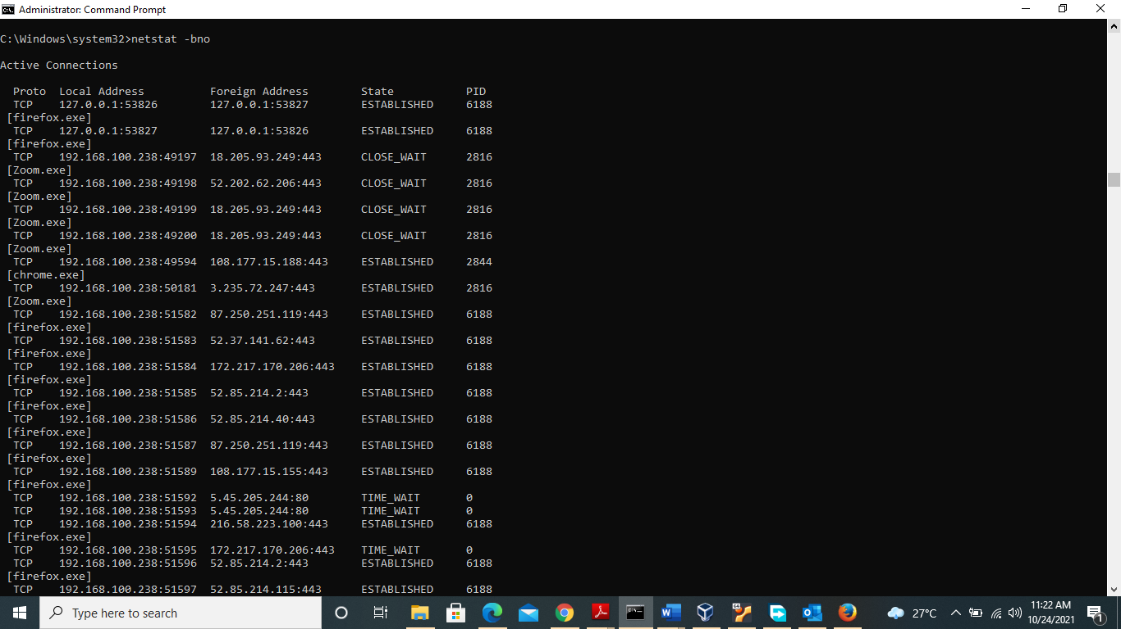

The ntestat -bno command displays all active connections their protocols, local ip address, foreign adress (external routers ) connection state and process identification.

Local ip address is static but changes ports for each connection while the foreign ip address changes per connection but maintains the same port 80 or 443 respectively. Connections throuhh port 80 were noticed to be in a Time_wait State and were not assigned any process id. Established connections of the same executable file had the same PID.

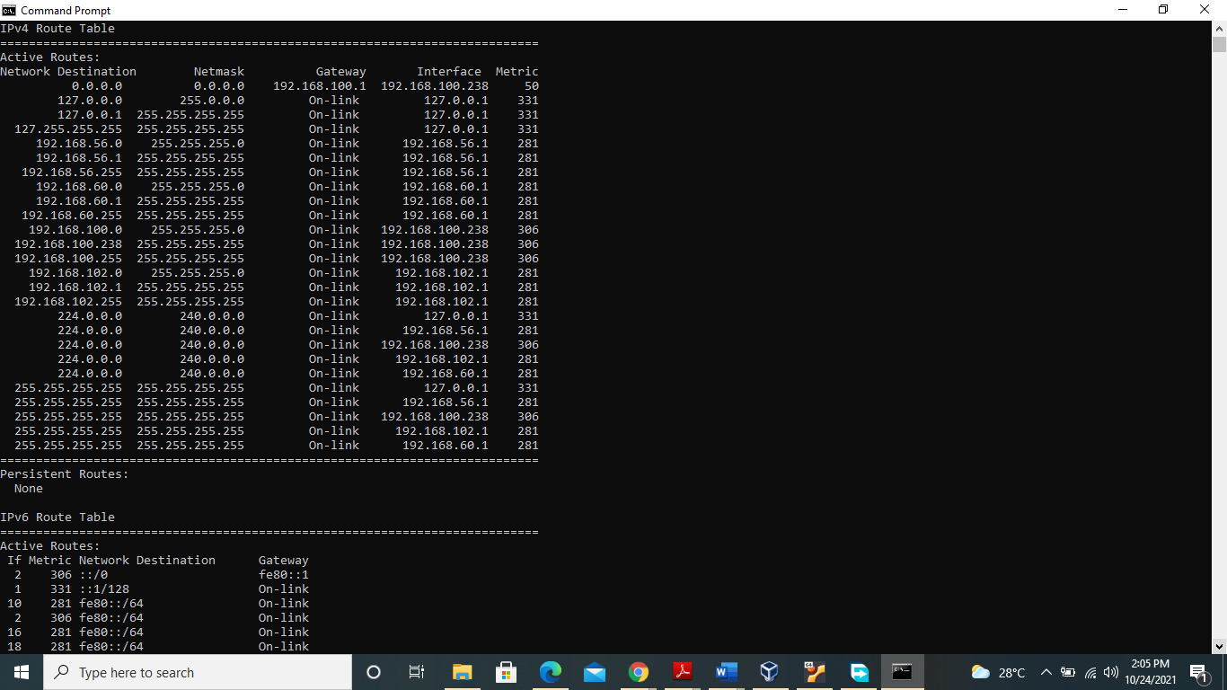ROUTING TABLE ENTRIES .

Command used to display routing table netstat -r

Ip address 192.168. 100.238, Netmask 255.255.255.255 are of the network class C.

REFERENCES

Understand TCP/IP addressing and subnetting basics <https://docs.microsoft.com/en-us/troubleshoot/windows-client/networking/tcpip-addressing-and-subnetting>

Netstat command examples and its usage <https://www.slashroot.in/netstat-command-examples-and-its-usage>

TCP/IP and Data Communications Administration Guide. <https://docs.oracle.com/cd/E19504-01/802-5753/6i9g71m3i/index.html>